Contents

Introduction 1

Abstract 1

Problem Statement 1

Aim 1

Objectives 1

Report Format 1

Literature Review 1

Approaches to the Stock Market 1

Expert Systems and external factors 1

Quantitative Analysis 1

Day trading 1

AI Approaches to the Stock Market 1

Hybrid System of Expert Systems and Quantitative analysis 1

AI being applied to Day Trading 1

# Introduction

A user looking into a Stock Market realises ample opportunities for growth and profit. A successful buying and selling of a security generates profit using the basic and unitary concept of “buy low, sell high”. This concept can be applied to a myriad of different trading examples. Bulk buy printers at £300 a unit and sell at £500 a unit and one can see himself with £200 profit per item sold.

The same concept is applied to the Stock Market. Hundreds of companies go public to open their shares to investors in hopes of gaining easy access to a large capital. This opens up a relationship with market participants ranging from individuals, investment banks, and insurance companies all with their own applied methods of when would be the right time to purchase and sell stock.

However, the multiple system’s put in place to make a profit out of the market are not necessarily reliable. Different schools of thought dictate the market to be random and a gamble outside of economic analysis, while some parties claim to be making a profit out of these gambles.

This report breaks down the different methods used to make a profit from market movement and narrows down on technical time series analyses. Different methods of this analysis are evaluated and the way machine learning can have an effect on this is discussed.

## Abstract

## Problem Statement

Day trading is a newer approach to solving the stock market. Fundamental analysis is ignored and technical analysis is applied instead, traders opt for short term profits (within the day) whereas stock-brokers look to invest over long term periods.

However many experts and specialists claim that day-trading is a form of gambling and that stock movement outside of economic/business factors are entirely random.[1(EMH)] However day-trading has been a tactic for decades and there have been made many rules and regulations around it.[2(DT)]

This report will attempt to understand whether different day-trading tactics have merit and if it’s repeatable. If so my program will aim to create algorithms of the analysis techniques and check whether in historical data these techniques can repeatedly output a profit.

Further from that I will aim to analyse the different analysis algorithms and compete them to be able to tier the different tactics.

Room exists for AI and automated trading to have worthwhile implementation. Day-trading can take up long schedules in individual’s days, and the rule-systems that they have in place can translate well into machine.

The value of a company’s share multiplied by the amount of shares available for purchase determines a company’s market cap.[3(invest)] Therefor the stock price is a major part of the representation of a company’s value itself. But how is this value figured out? There are no calculations to determine what the world value’s a company.

This is instead a reflection by their performance, most notably in their turnover.

Before we break down how entities predict stock price movement, we must first discuss the value of the stock itself. Share price multiplied by amount of shares available for purchase dictate a company’s market cap.

But how is share price determined? How is Tesla’s stock currently $333.04 at the time of writing. When a company decides to become public it goes through an Initial Public Offering (IPO). This process has many steps, one of the main ones being the pricing. Here, large banks work with the company to determine what they believe the company to be worth and how many shares to split up the worth by. The price offering is then released to the public where potentially thousands of investors queue up to purchase the stock.

From here it’s a game of supply and demand. The amount of stock that a company puts out is limited. A trillionaire can’t just off the whim decide to purchase all the stocks of Facebook. This static supply causes the demand of the stock to be the main, if not sole factor, in deciding the worth of the company. Everything else is succeeded by the demand.

Therefor to capitalise on the idea of buying low and selling high, investors must use techniques to predict when a company’s value is expected to be increased by a surplus in demand or expected to decrease by a withdrawal of demands.

Understanding these behaviours, despite being quite nuanced, is simple for the everyday person to see. Apple is a simple example. In 2007 despite being public for decades their share price was only $12.15. As the popularity of their products such as the iPod and the iPhone started increase, in turn increasing their revenue, more and more stake holders started taking notice.

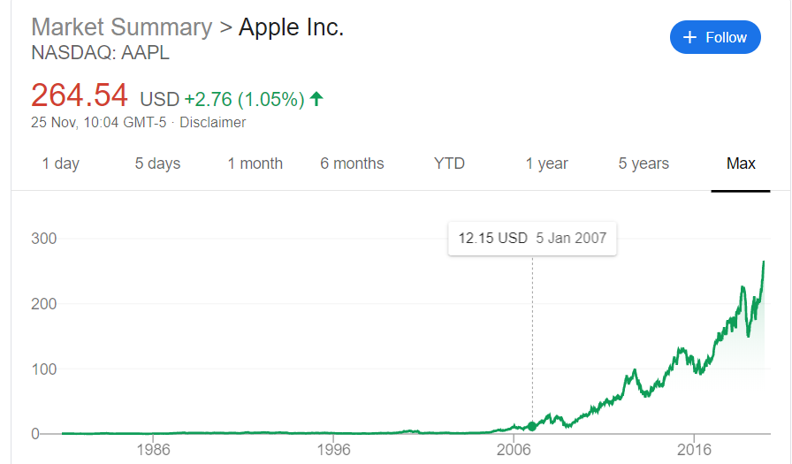

Fig 1.2

Fig 1.1

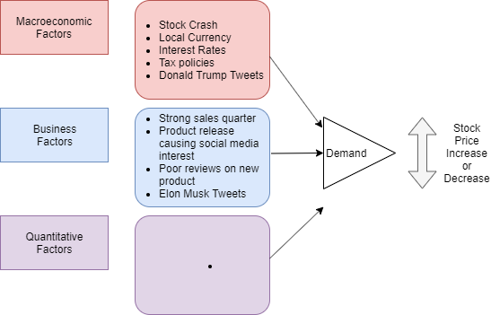

As Apple became more prolific in the public eye different investors around the world started speculating that Apple would only get bigger. They wanted to be a part of the company itself, a shareholder. This resulted in enormous amounts of investors flocking to Apple to purchase their stock with the hopes of receiving dividend checks but more importantly in cashing out once the stock price reaches a huge level.

As an example let’s consider an individual who purchased 100 shares of Apple on 5th January 2007 costing him $1215, reasons of doing so being dismissed. If he were to sell all 100 stocks on 25th November 2019 (in time of writing), he’d receive $26454. That’s over $25000 of profit (dismissing dividend payments) from only putting an initial capital dump of $1200.

This is the investor’s ideal and dream scenario. Of course for every Apple there are thousands of other companies who do not perform the same, Apple being unicorn like in their rise. And for every investor who bought in on January 2007 there are thousands of investors who bought in to Apple in 2018 when their stock price was already into the hundreds.

Considering the above example, that particular investor made a 2000% profit over 12 years. If we consider the amount of money that investment banks and hedge funds are willing to spend in investments, a million dollar buy in soon becomes a billion.

With this simple flow of money it becomes quite clear on why stock investment has so many minds and methods behind it. The money to be made is astounding.

## Aim

The aim of the project is to establish different stock-market prediction techniques and how trading can be used to predict seemingly random movement. To then understand how this can be aided my machine learning. The program made will then be able to match chart patterns with market movement and use data mining to rank the different chart patterns.

## Objectives

* Develop a clear explanation to the limitations of day trading on stock prices and thereby the limitations of AI analysis on day-trading profit making.
* Create algorithms that suitably represent different rules used by day traders.
* Read in historical stock-price data using an API and match algorithms to the chart patterns.
* Be able to match how chart patterns link to market movement and then tier the observed rules.
* Finish the product to be able to function live and use an assortment of the chart patterns in decision making for buying stock.

## Report Format

# Literature Review

## Approaches to the Stock Market

Beating the market

### Fundamental Analysis (Expert Systems and external factors)

Fundamental analysis is the idea of understanding a company’s history combined with the industry they lie in and which economic region they lie in. All these things considered, investors can make decisions on their purchases. Such things to consider are: a company’s quarterly records, them performing higher than expected; industry rivals, a competitor potentially stealing the company’s market share; state of the nation’s economics, if FTSE 100 have been declining for a long period of time this is an indication of a UK company’s stock not rising either.

Fundamental analysts spend their whole lives learning about the relationship between various financial factors and a company’s stock price. Banks hire analysts by the thousands in a single city alone.

However many questions have been raised on the worth of stock market predictions. Investors such as Warren Buffet and more notably Jack Bogle have made their worth on not trying to beat the market, but to invest in the market itself and gaining profit from the increase in the market. This is obviously backed up by the fact that stock markets, despite the numerous crashes continue to grow.

These 2 investors advise to spread your investments, with the latter even coming up with the idea of index funds. So with this tried and tested method why do companies and individuals attempt to forecast growth? Entities insist on beating the market for a faster rate of return, essentially people want more money and they want it sooner.

Trader psychology is a huge factor on why index investors don’t believe you can beat the market.[4] This is more so backed up by a research paper conducted in 1932. In this paper there is a discussion comparing how insurance companies and financial services perform in forecasting stock prices. Results from 45 organisations were gathered, mainly from magazine publication with their recommendations.

The results of the organisations come with the underline of how the predictions scored related to market averages. That is to say if the market increased by 5% and a particular prediction increased by 2.5% this would result in a score of -2.5%. And minus scores is what is seen across this paper. Table 4 shows us 24 randomly selected results. 10/24 (42%) of the forecasts beat the market with the remaining 58% having lost to the market.

This low score of beating the market is reiterated in multiple results of this paper with only 12/36 (33%) financial services and insurance companies beating the market. If specialists could not fare to beat the market then it makes sense to “bet” on the market itself. Again, investors don’t simply want to beat the market, they want to beat everybody else beating the market. This point of winners and losers tie on later.

Importantly, the results of this paper must be analysed. Results were taken in USA in 1932. If one were to look at historical data of large indices, NASDAQ, FTSE, Dow Jones etc there can almost be a guaranteed visual of market prices increasing.

Market crashes result in huge slumps of stock prices, investor confidence being at the low. Low confidence means low demand meaning rapid selling of stock leading to stock prices plummeting, leading to crashes. If you take another step back and plot in a straight line how different indices have performed since the start of prices being stored, you will see a line with a positive gradient. The market always increases.

This leads onto the results of the paper being taken at 1932. Only a few years after the great depression, though households struggle and companies hit historic lows, the direction the market takes following a crash is quite constant. That direction is up.

I therefor argue that beating the market in 1932 or other rising economy periods is a difficult task, regardless of whether it is an expert or a novice investor attempting to do so. None the less, these companies could not beat the market.

The sentiment I received from this paper was quite anti-investment. The creation of index funds, such as those offered by The Vanguard Group, from 1960’s onwards however can tackle the issues presented by the paper. Instead of aiming to beat the market, individuals can bet with the market and receive returns that are overall average. This is quite commonplace, with banks and pensions funds opting to use different indices to receive returns that overtime looks to be generous.

This of course is not enough; individuals and banks look towards methods to beat the average, to increase their returns. When given the option of taking £10 off of an individual and promising them either £50 in 30 years’ time versus risking it to £20 tomorrow, different entities will have different psychologies towards this.

### Quantitative Analysis

### Day trading

## AI Approaches to the Stock Market

### Hybrid System of Expert Systems and Quantitative analysis

### AI being applied to Day Trading

## Proposed solution

### Issues with current solutions

### Objectives to fix these solutions